**Course: Advance Bio Informatics**

**Module Title: Problems for NLP**

**Module No: 97**

**Problems for NLP**

* Incomplete Knowledge
* Ambiguity
* Compactness
* Terms variety for BD

**Problems for NLP**

(1) **Robustness:** Incomplete Knowledge

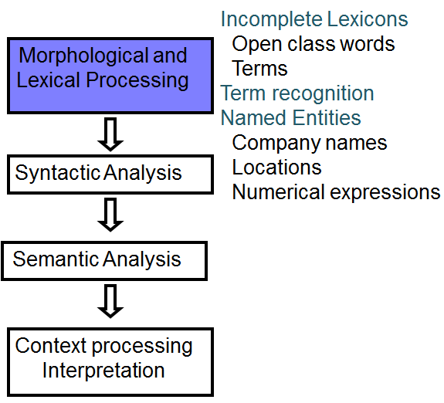

(1) **Robustness:** Incomplete Knowledge

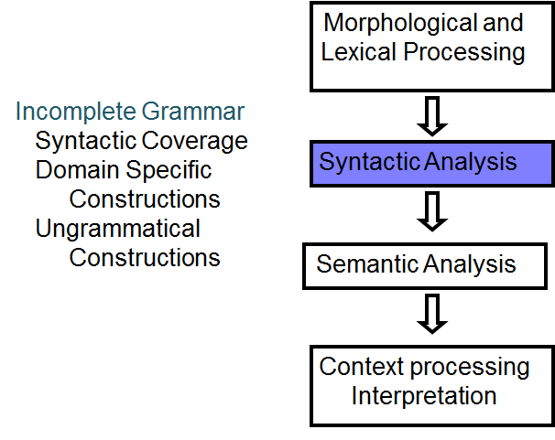

(1) Robustness: Incomplete Knowledge

